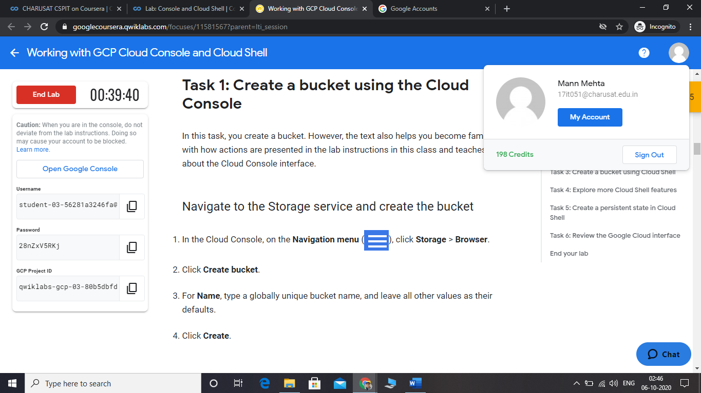

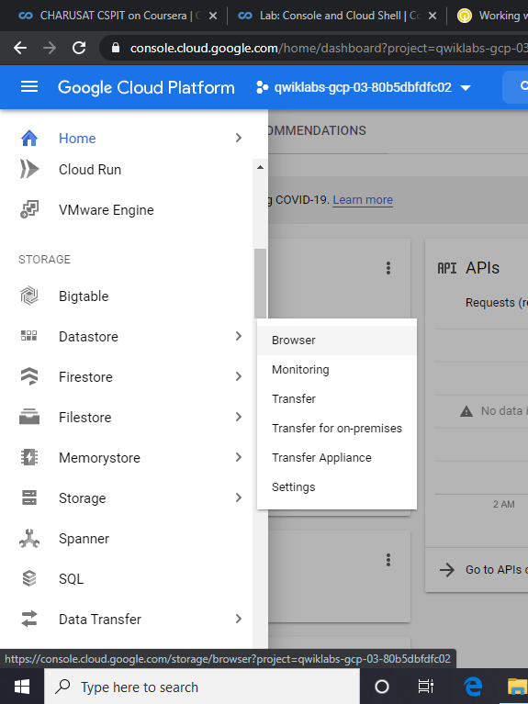

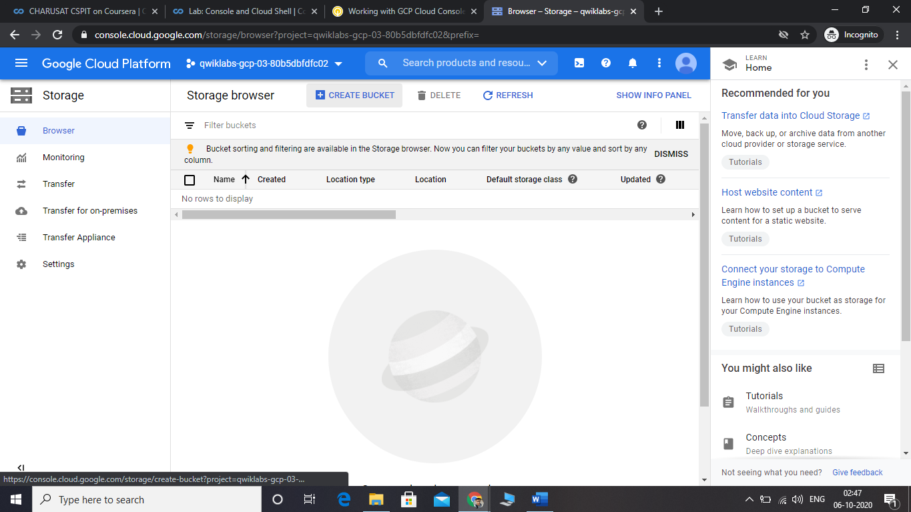

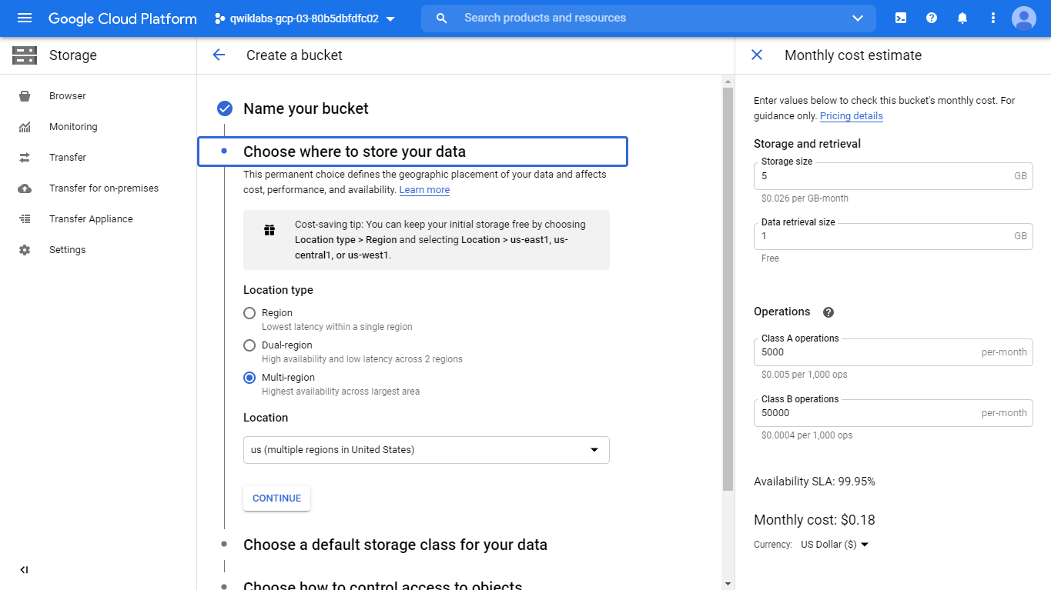

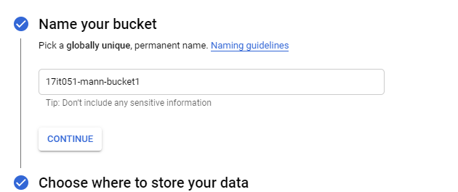

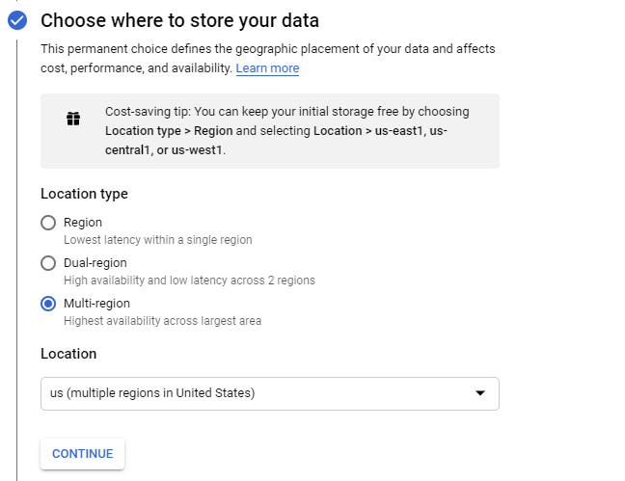

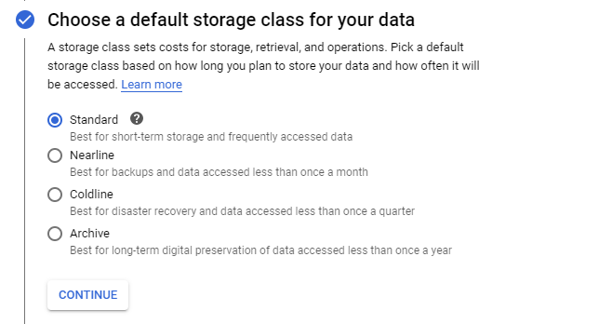

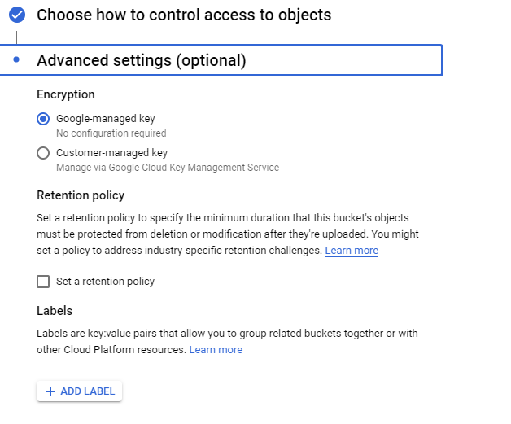

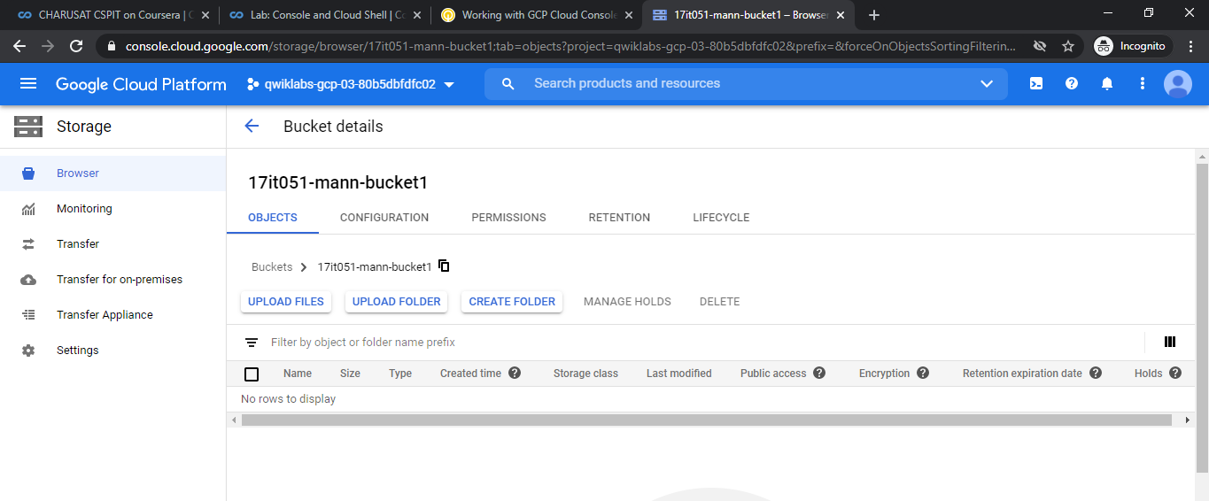

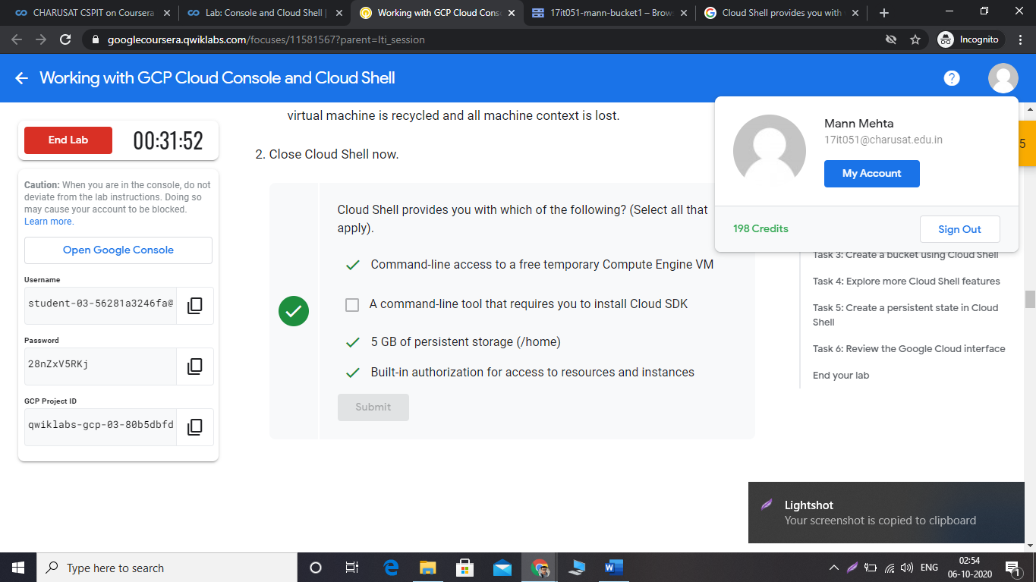

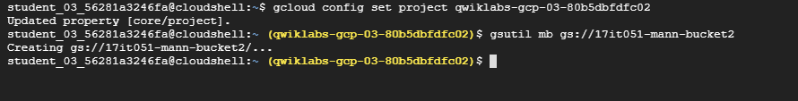

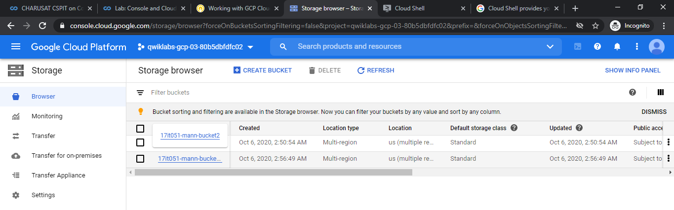

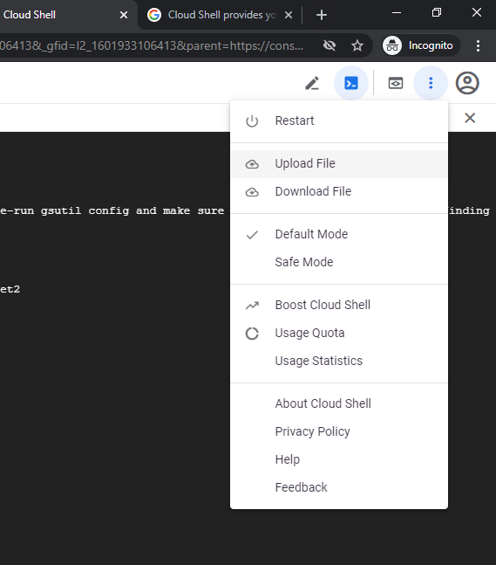

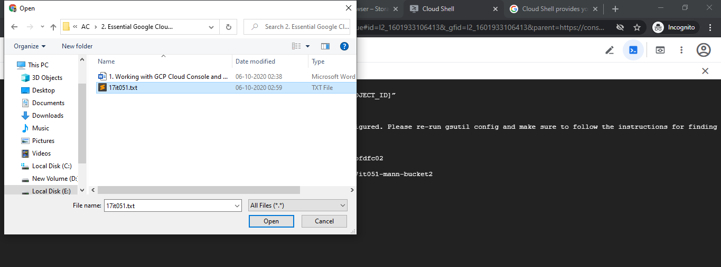

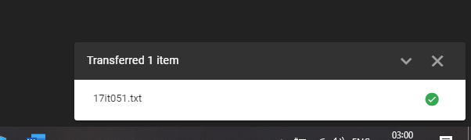

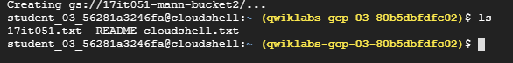



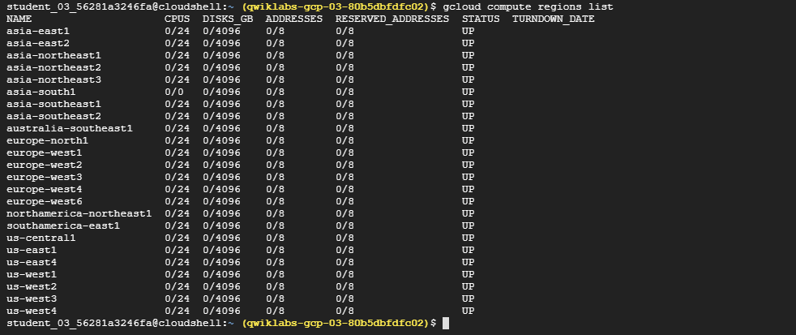

student_03_56281a3246fa@cloudshell:~ (qwiklabs-gcp-03-80b5dbfdfc02)$ gcloud compute regions list

NAME CPUS DISKS_GB ADDRESSES RESERVED_ADDRESSES STATUS TURNDOWN_DATE

asia-east1 0/24 0/4096 0/8 0/8 UP

asia-east2 0/24 0/4096 0/8 0/8 UP

asia-northeast1 0/24 0/4096 0/8 0/8 UP

asia-northeast2 0/24 0/4096 0/8 0/8 UP

asia-northeast3 0/24 0/4096 0/8 0/8 UP

asia-south1 0/0 0/4096 0/8 0/8 UP

asia-southeast1 0/24 0/4096 0/8 0/8 UP

asia-southeast2 0/24 0/4096 0/8 0/8 UP

australia-southeast1 0/24 0/4096 0/8 0/8 UP

europe-north1 0/24 0/4096 0/8 0/8 UP

europe-west1 0/24 0/4096 0/8 0/8 UP

europe-west2 0/24 0/4096 0/8 0/8 UP

europe-west3 0/24 0/4096 0/8 0/8 UP

europe-west4 0/24 0/4096 0/8 0/8 UP

europe-west6 0/24 0/4096 0/8 0/8 UP

northamerica-northeast1 0/24 0/4096 0/8 0/8 UP

southamerica-east1 0/24 0/4096 0/8 0/8 UP

us-central1 0/24 0/4096 0/8 0/8 UP

us-east1 0/24 0/4096 0/8 0/8 UP

us-east4 0/24 0/4096 0/8 0/8 UP

us-west1 0/24 0/4096 0/8 0/8 UP

us-west2 0/24 0/4096 0/8 0/8 UP

us-west3 0/24 0/4096 0/8 0/8 UP

us-west4 0/24 0/4096 0/8 0/8 UP

